



CASE STUDY I

SUBMITTED BY: SUBMITTED TO:

Mandip Shrestha Anand KC

Rijan Rijal
Bipin Dawadi

TABLE OF CONTENT

TABLE OF CONTENT 2
CHAPTER 1 4
BANK E-SERVICE 4
Installation Process 4
Registration and Login 4
Key Features and Usage 4
Snapshots 4
Figure:1.1 App installation from play store 5
Figure:1.2 Login/registration page 5
Figure:1.3 Home Dashboard 5
Figure:1.4 Payment or Transfer Screen 5
CHAPTER 2 6
CONNECTIPS 6
Installation Process 6
Account Registration and Bank Linking 6
Key Features and Usage 6
Snapshots 6
Figure:2.1 Website Registration 7
Figure:2.2 Banking linking…………………………………………………………………….7
Figure:2.3 Fund Transfer 8
Figure:2.4 Bill payment 8
CHAPTER 3 9
NAGARIK APP 9
Installation Process 9
Account Setup and Document Linking 9
Key Services Offered 9
Snapshots 9
Figure:3.1 App installation 10
Figure:3.2 Login Signup page 10
Figure:3.3 Dashboard 11
CHAPTER 4 12
ESEWA 12
Installation Process 12
Account Creation and Setup 12
Core Services and Usage 12
Snapshots to Include 12
Figure:4.1 App Installation 13
Figure:4.2 Login Signup page 13
Figure:4.3 Home Page 14
Figure:4.4 QR scan 14
Conclusion 15

CHAPTER 1

BANK E-SERVICE

Installation Process
To begin using Bank E-Service, users need to install their bank's official mobile banking app. The process starts by visiting the Google Play Store or Apple App Store and searching for the respective bank's application, such as "Global IME Smart Banking," "Nabil SmartBank," or "NIC Asia MoBank." Once found, users tap on the "Install" button to download and install the app on their device.

Registration and Login
After installation, the user launches the app and begins the registration process. Typically, this involves entering their bank account number or the mobile number linked to their account. The user is then prompted to create a secure login credential, such as an MPIN or password. An OTP (One-Time Password) is sent to the registered mobile number to verify the user's identity and complete the sign-up. Some banks may also require branch-level activation for first-time users.

Key Features and Usage
Bank E-Service applications offer a wide range of features designed to make banking more convenient and accessible. Users can:
- Check account balances in real-time.
- View mini statements for recent transactions.
- Recharge mobile phones and pay internet or electricity bills.
- Transfer funds to other accounts within the same bank or to different banks using interbank transfer services.
- Request account statements, manage debit cards, and locate nearby ATMs or branches.

These features reduce the need for in-person visits and save valuable time for users, especially in rural or busy urban areas.

Snapshots:

App installation from Play Store Login/registration page

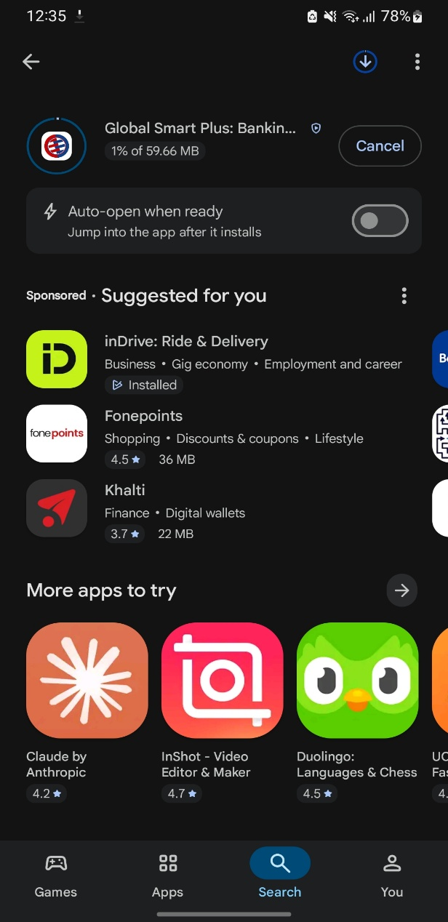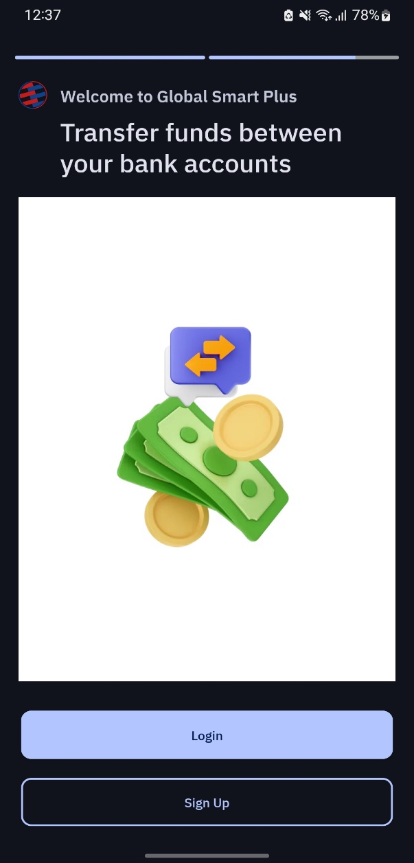
Figure:1.1 App installation from Play Store Figure:1.2 Login/registration page

Home dashboard Payment or transfer screen 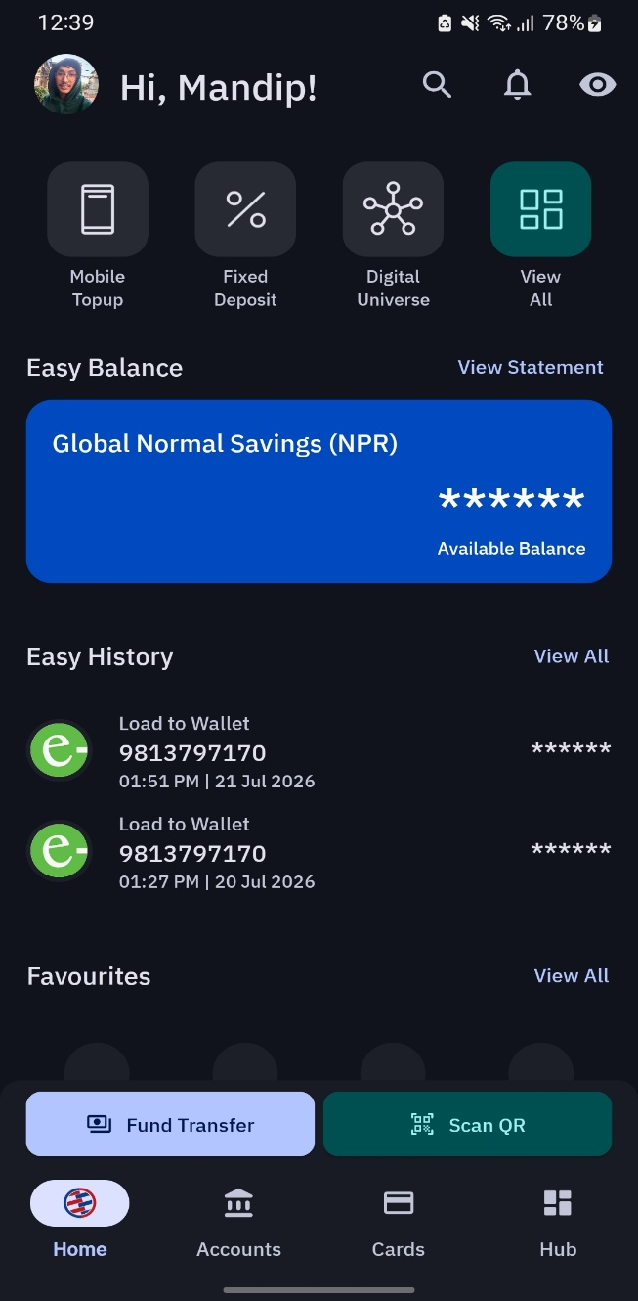 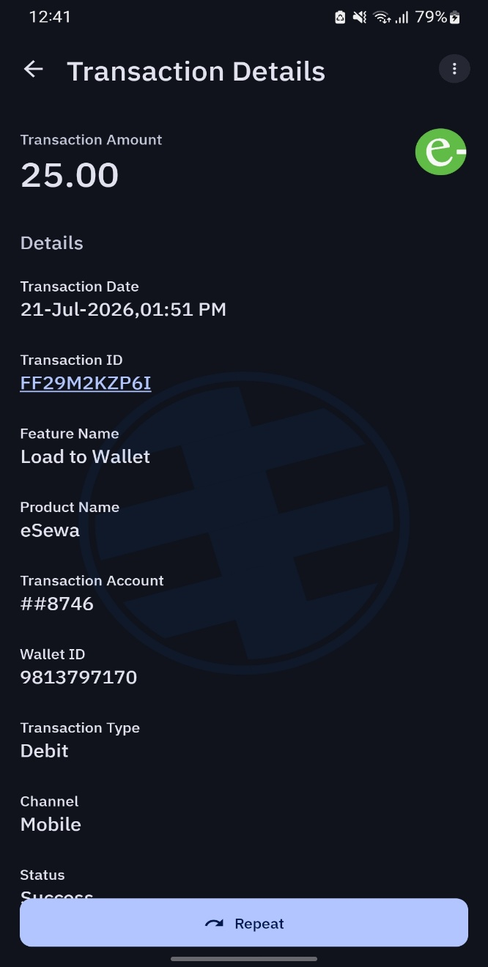
Figure:1.3 Home dashboard Figure:1.4 Payment or transfer screen

CHAPTER 2

CONNECTIPS

Installation Process
ConnectIPS is a digital payment platform initiated by Nepal Clearing House Limited (NCHL), allowing users to make interbank transfers and pay utility bills or government charges. To begin, users can either visit the official website www.connectips.com or download the “ConnectIPS” mobile application from the Google Play Store or Apple App Store. The installation process is simple and completes within a few minutes.

Account Registration and Bank Linking
After installation or website access, users must register by providing a valid mobile number and email address. Once verified through an OTP, the user proceeds to link their bank account. This involves selecting their bank from the provided list, entering account details, and submitting the request for verification. The bank typically approves the request within one to two business days. Some banks may require additional in-person verification or mobile/email confirmation.

Key Features and Usage
Once the account is active and linked, users can log in using their set credentials. Inside the platform, they can:
- Access and manage multiple linked bank accounts.
- Transfer funds directly to any bank account in Nepal via interbank services.
- Pay electricity bills, water bills, internet charges, and insurance premiums.
- Settle government payments like taxes, fines, passport fees, and even deposits to the Citizen Investment Trust (CIT).
- Use scheduled payments or authorize payments using a secure transaction PIN.

The platform is widely trusted for both personal and business use due to its central integration with government and banking systems.

Snapshots:
Website/App registration Bank linking

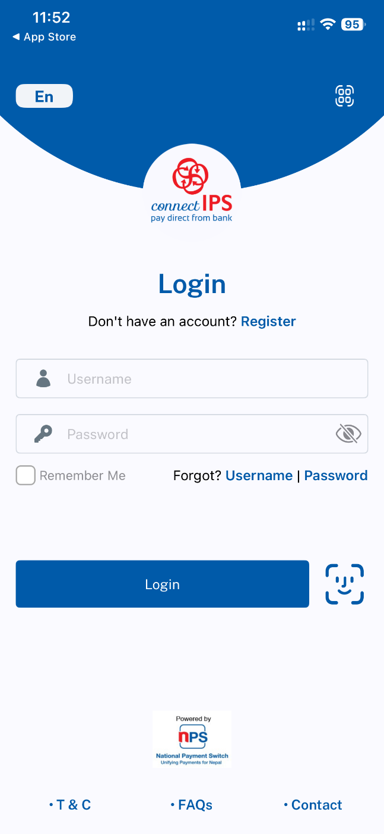

Figure:2.1 App Registration Figure:2.2 Bank linking

Fund transfer screen Bill payment screen
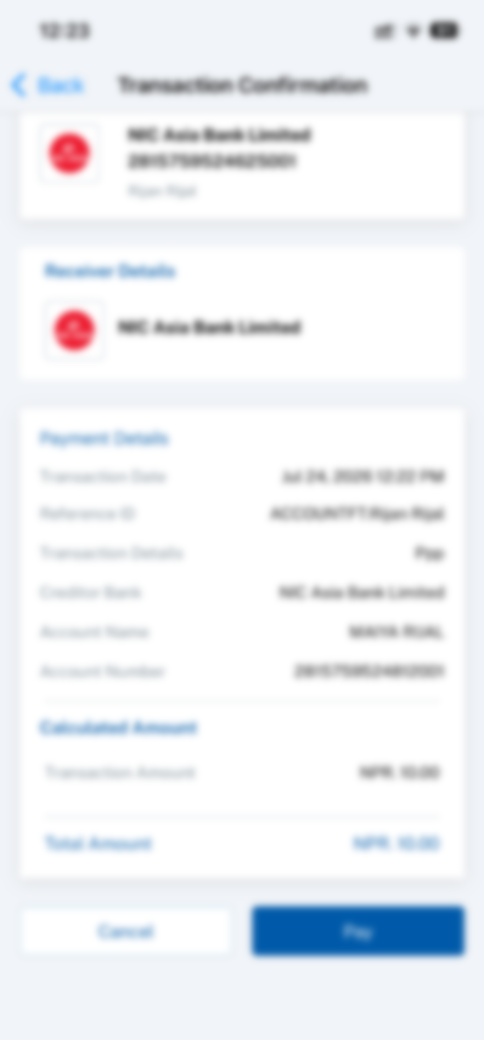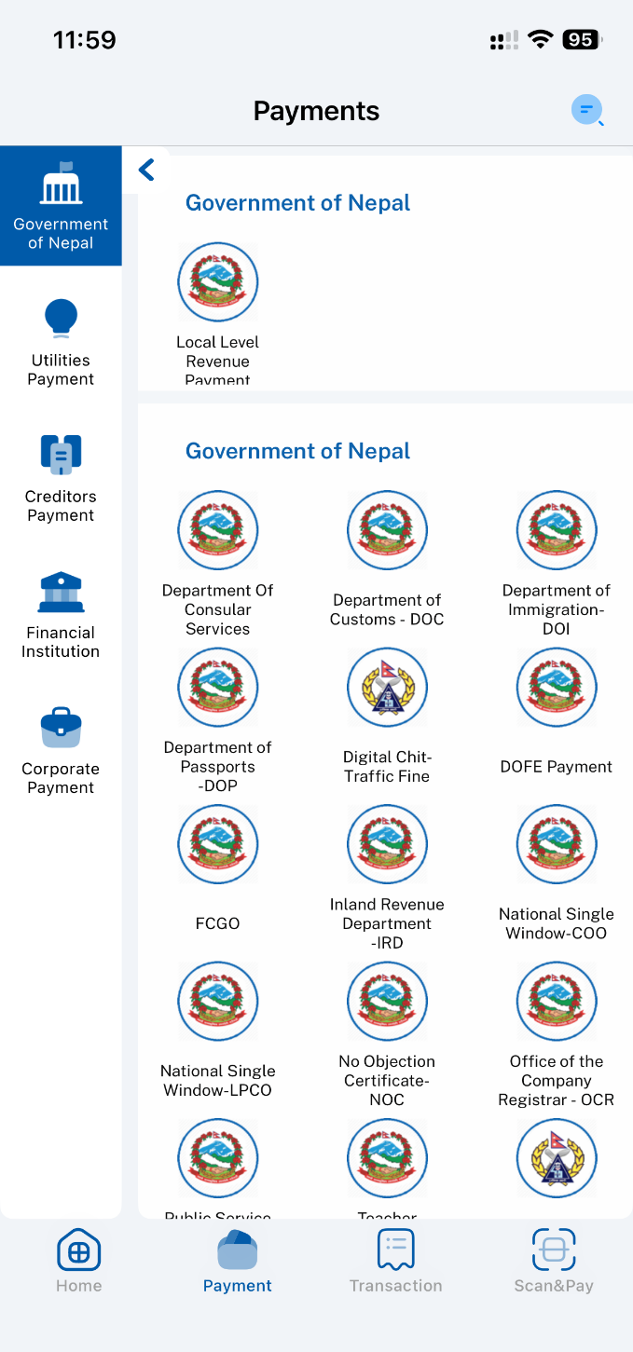

Figure:2.3 Fund Transfer Figure:2.4 Bill payment

CHAPTER 3 NAGARIK APP

Installation Process
The Nagarik App is a government-initiated mobile application that serves as a centralized platform for accessing multiple public services. It is available for free on both the Google Play Store and Apple App Store. Users can install the app by simply searching for “Nagarik App” and tapping the install button.

Account Setup and Document Linking
After installation, users begin the registration process by entering their active mobile number. To verify their identity, the system requests the user's citizenship number, date of birth, and the province where their citizenship was issued. Once verified, users can link additional personal documents such as their PAN (Permanent Account Number), driving license, voter ID, passport, and more. This allows the app to serve as a digital wallet for key government-issued documents and credentials.

Key Services Offered
The Nagarik App offers a range of services and document access features, including:

- Digital viewing of Citizenship information, PAN details, and Passport status.
- Access to Nagarik Lagani Kosh (Citizen Investment Trust) details.
- Retrieval of academic certificates issued by universities and educational boards.
- Application status and download of Police Clearance Reports.
- Display of the Covid-19 vaccination certificate and other health records.

The app acts as a gateway to paperless governance, reducing the need to physically visit government offices for verification and services.

Snapshots:
- App installation

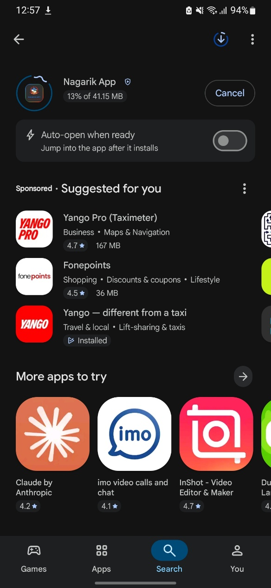

Figure:3.1 App installation

Login/sign up page
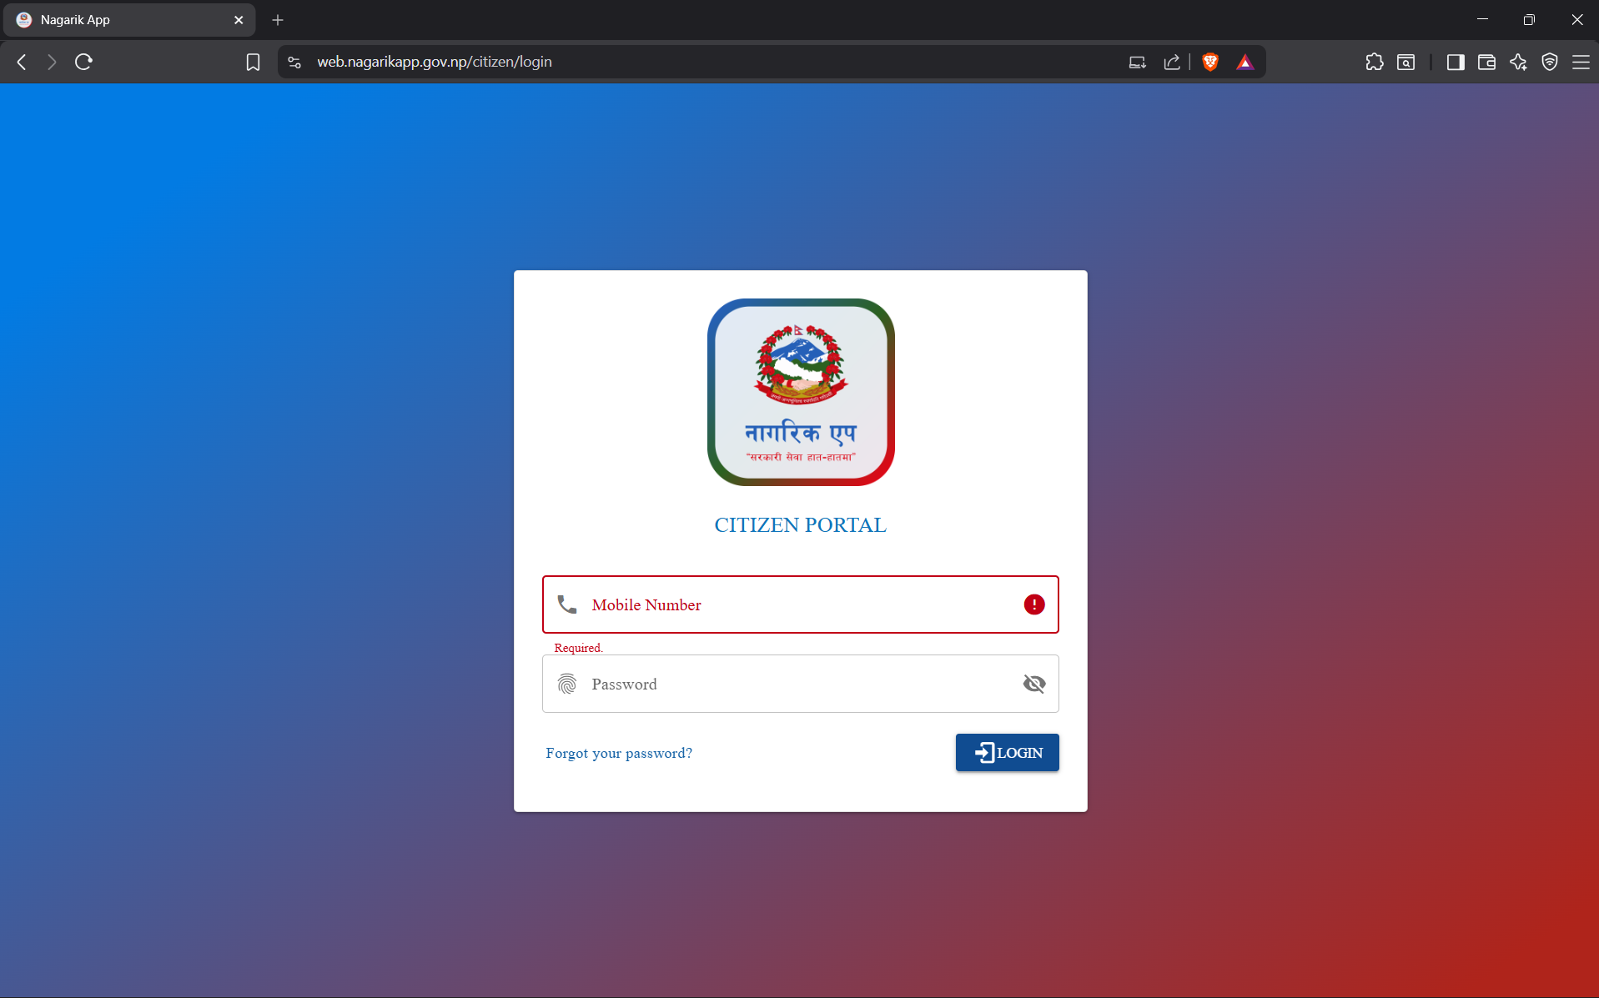
Figure:3.2 Login Signup page

Dashboard
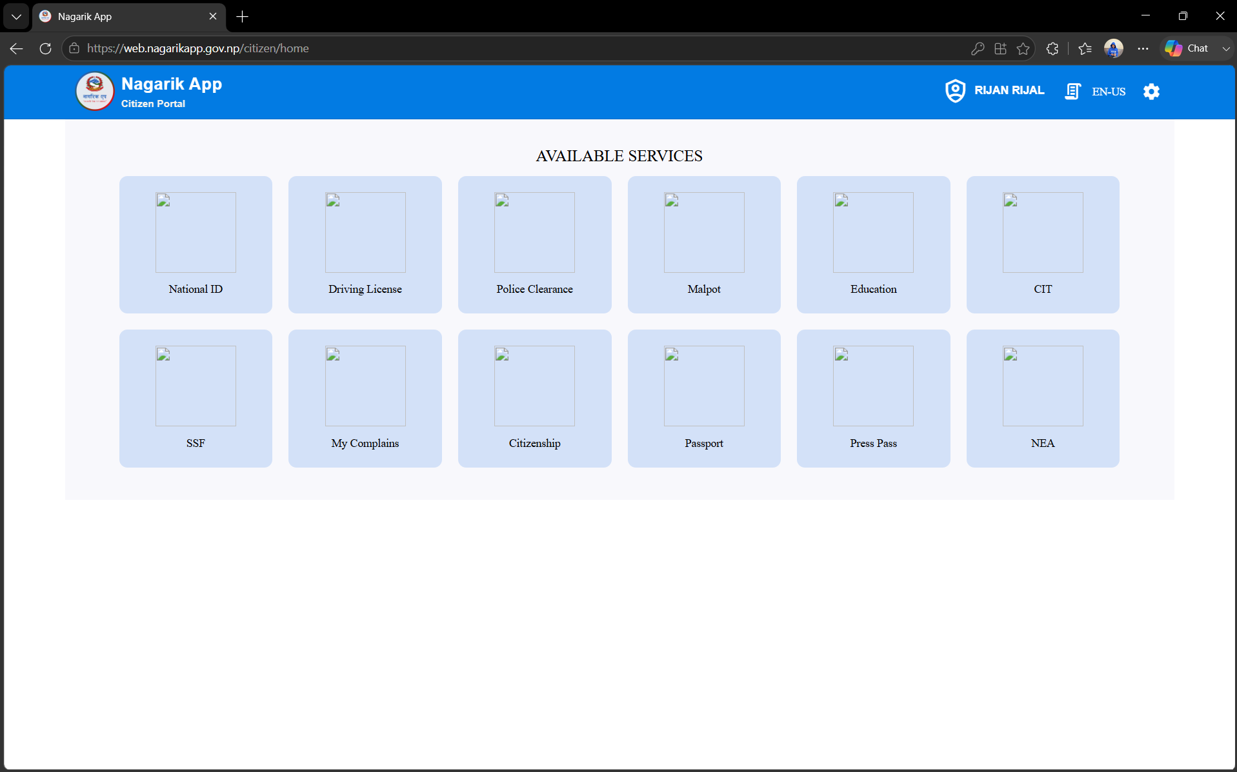
Figure:3.3 Dashboard

CHAPTER 4 ESEWA

Installation Process
eSewa is Nepal’s first digital wallet and is widely used for financial transactions. It can be installed from the Google Play Store or Apple App Store by searching for “eSewa” and tapping the install option. The app is lightweight and installs quickly on most smartphones.

Account Creation and Setup
Once installed, users register by providing a mobile number. They are prompted to create a secure password and set an MPIN for transaction authentication. The mobile number is verified using an OTP. For enhanced features like bank-to-wallet transfers or higher transaction limits, users can optionally link their eSewa account to a bank.

Core Services and Usage
eSewa offers a broad range of digital services catering to everyday needs, such as:

- Mobile top-ups and recharge for all major telecom providers.
- Utility bill payments including NEA electricity bills, Khanepani (drinking water), and internet charges.
- School and college fee payments for various educational institutions.
- Online booking of domestic flight and intercity bus tickets.
- QR code-based payments at local shops, restaurants, and vendors.

With a user-friendly interface and wide acceptance, eSewa has become a go-to platform for cashless transactions across Nepal.

Snapshots to Include
Visuals for this chapter may include:

App installation screen from the Play Store. Registration and Login page.

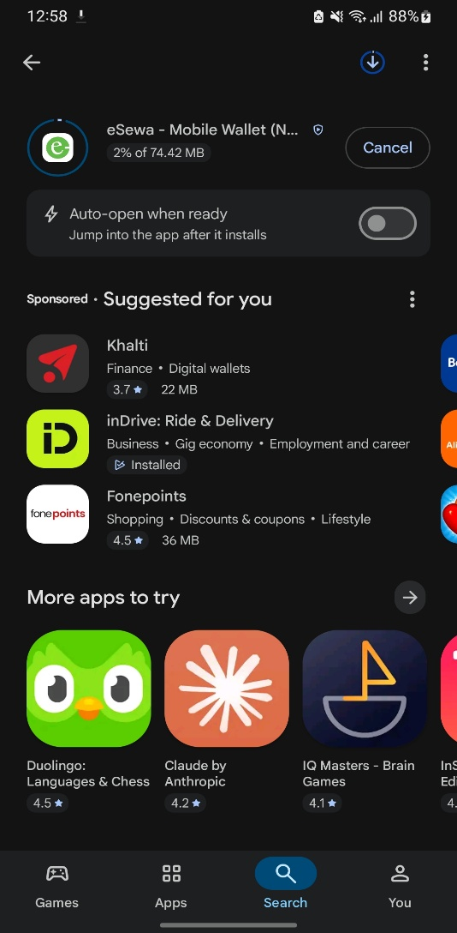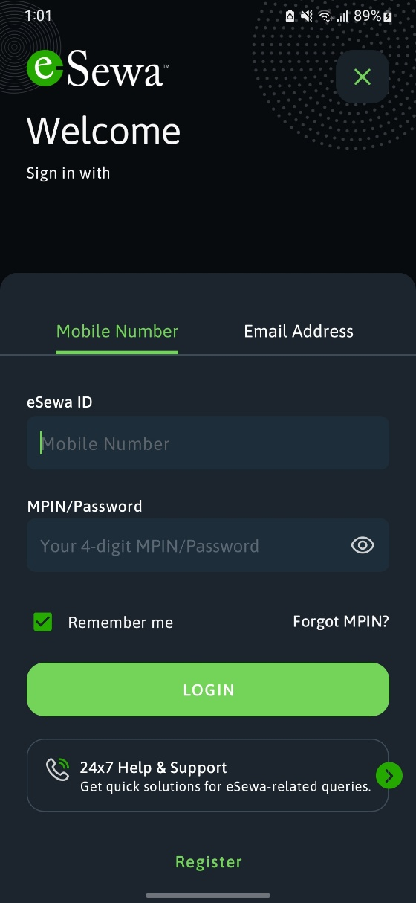
Figure:4.1 App Installation Figure:4.2 Login Signup page
Home dashboard showing services. A QR scan screen.

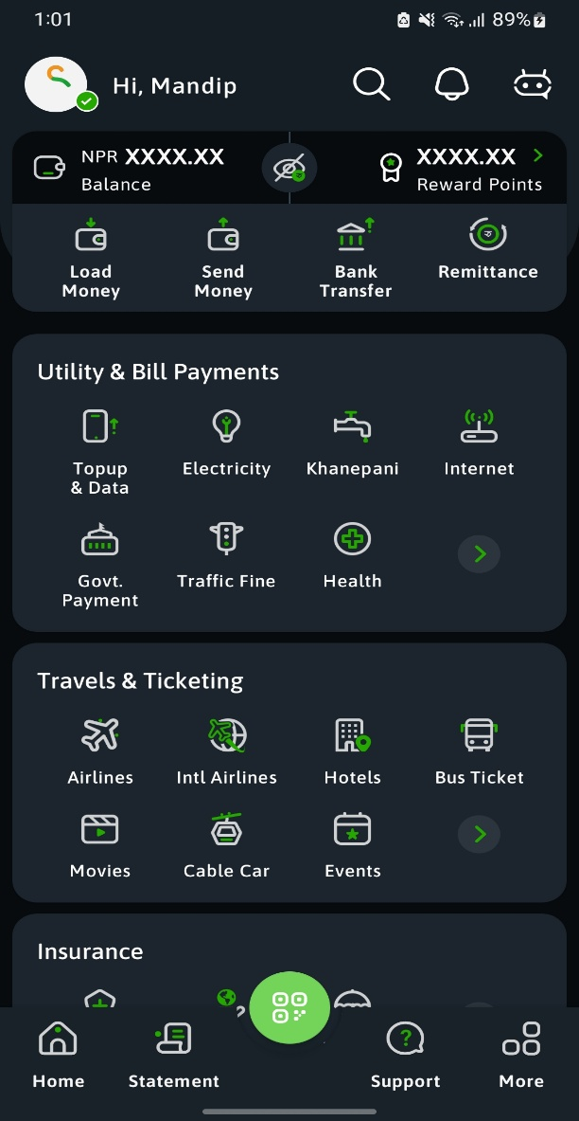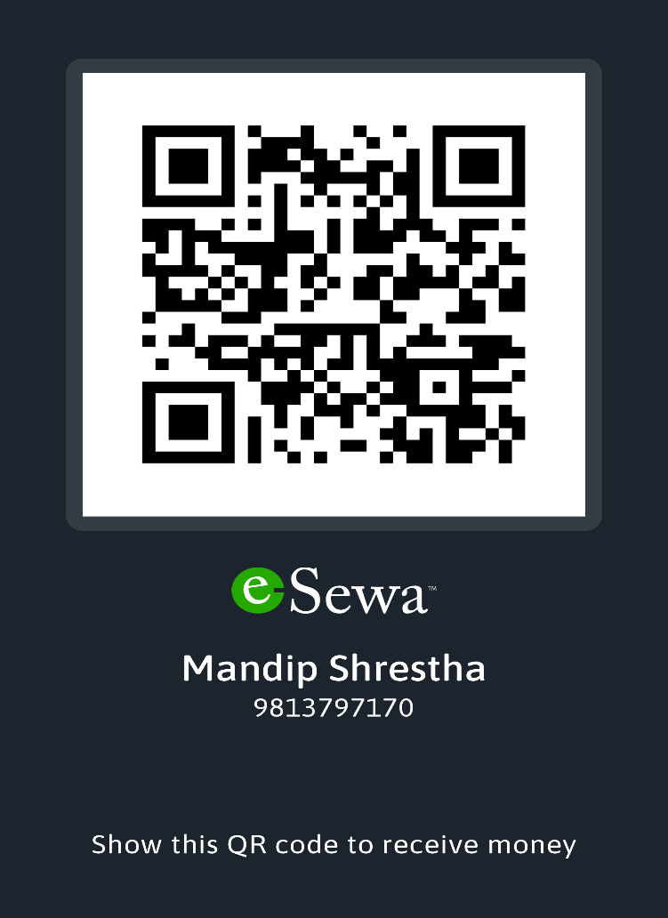
Figure:4.3 Home Page Figure:4.4 QR scan

Conclusion
The integration of digital services like Bank E-Service, ConnectIPS, Nagarik App, and eSewa has transformed the way individuals in Nepal manage their financial and civic responsibilities. These platforms offer user-friendly interfaces, simplified registration processes, and a wide range of essential services—from banking and utility bill payments to government document access and tax payments.
The convenience of downloading apps from the Play Store or accessing services through web portals has significantly reduced the need for in-person visits to banks, government offices, or payment centers. Especially in remote or rural areas, these tools have increased access to services that were once time-consuming and paperwork-heavy.
Despite some initial setup time (such as waiting for bank approval in ConnectIPS or verifying documents in Nagarik App), the long-term benefits in terms of efficiency, accessibility, and transparency are clear. As smartphone penetration and digital literacy continue to rise in Nepal, the use of such digital platforms is expected to grow even further.
This case study demonstrates that with the right awareness, user guidance, and trust, digital systems can meaningfully support Nepal’s journey toward a more connected, efficient, and citizen-centric service delivery ecosystem.

